भारत मौसम विज्ञान विभाग |  | India Meteorological Department
Sunday 03rd May 2026 (13th Vaisakha 1948 Saka)
Summary of observations recorded at 0830 hours IST: The Western Disturbance as a trough seen as a cyclonic circulation over north Pakistan & neighbourhood at 3.1 km above m. s. l. at 0530 hrs IST of today morning. It then persisted over the same region. However, the trough aloft in middle and upper tropospheric westerlies with its axis at 5.8 km above m. s. l. ran roughly along Long. 69°E to the north of Lat. 30°N. The upper air cyclonic circulation over north Haryana & neighbourhood lay over Haryana & neighbourhood and extended upto 1.5 km above m. s. l. A trough ran from the upper air cyclonic circulation over Haryana & neighbourhood to over Southwest Rajasthan at 0.9 km above m. s. l. The upper air cyclonic circulation over west Rajasthan & neighbourhood lay over southwest Rajasthan at 0.9 km above m. s. l. at 0530 hrs IST of today. It merged with the above trough at 0830 hrs IST. An upper air cyclonic circulation lay over Southeast Rajasthan & neighbourhood at 0.9 km above m. s. l. An upper air cyclonic circulation lay over East Madhya Pradesh & neighbourhood at 1.5 km above m. s. l. at 0530 hrs IST of today morning. It then persisted over the same region and seen at 0.9 km above m. s. l. The east-west trough ran from upper air cyclonic circulation over north Haryana & neighbourhood to Nagaland across Uttar Pradesh Bihar, Jharkhand, north Gangetic West Bengal, Bangladesh and south Assam at 0530 hrs IST of today morning. It ran from Punjab to Nagaland across upper air cyclonic circulations over Haryana & neighbourhood and East Madhya Pradesh, Bihar, Jharkhand, north Gangetic West Bengal, Bangladesh and south Assam extended upto 1.5 km above m. s. l. at 0830 hrs IST. The north-south trough ran from Chhattisgarh to Comorin Area across Telangana, Andhra Pradesh and Tamil Nadu at 0530 hrs IST of today morning. It ran from South Chhattisgarh to Comorin Area across Telangana, Andhra Pradesh and Tamil Nadu extends upto 1.5 km above m. s. l. at 0830 hrs IST. An upper air cyclonic circulation lay over Central Assam & neighbourhood at 3.1 km above m. s. l. The upper air cyclonic circulation over north Bangladesh & adjoining Gangetic West Bengal lay over northeast Bangladesh at 0530 hrs IST of today morning. It then persisted over the same region and extended upto 1.5 km above m. s. l. However, the trough aloft with its axis at 3.1 km above m. s. l. roughly along Long. 91°E to the north of Lat. 24°N became less marked.
Maximum Temperature Departures (as on 02-05-2026): Above normal (2.0°C to 4.0°C) over Jammu-Kashmir, West Rajasthan, Telangana, South Coastal Andhra Pradesh, Tamil Nadu, Puducherry & Kerala. Below normal (3.0°C to 6.0°C) over Uttarakhand adjoining Himachal Pradesh and east Haryana, Northeast Rajasthan, Northwest &east Madhya Pradesh, Uttar Pradesh, North Chhattisgarh, east and northeast India and near normal over rest parts of the country. The highest maximum temperature of 44.4°C was reported at Jaisalmer (Rajasthan).
Hailstorm reported over Himachal Pradesh, Maharashtra, Jharkhand, Uttarakhand, Madhya Pradesh.
Duststorm reported over Rajasthan and West Uttar Pradesh.
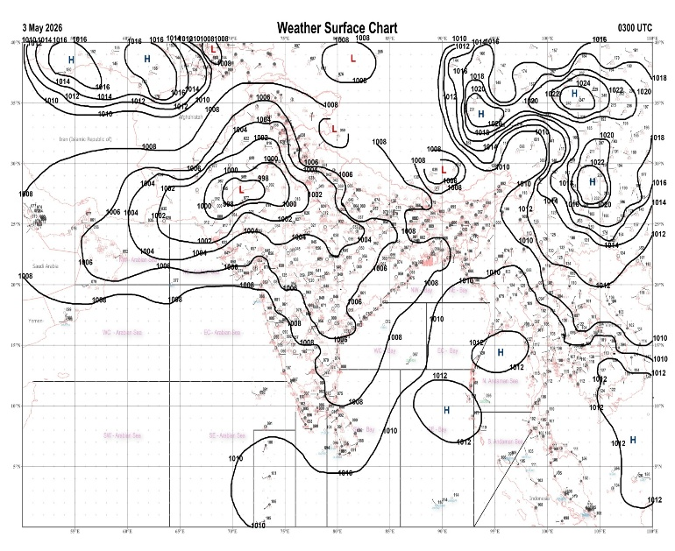 | 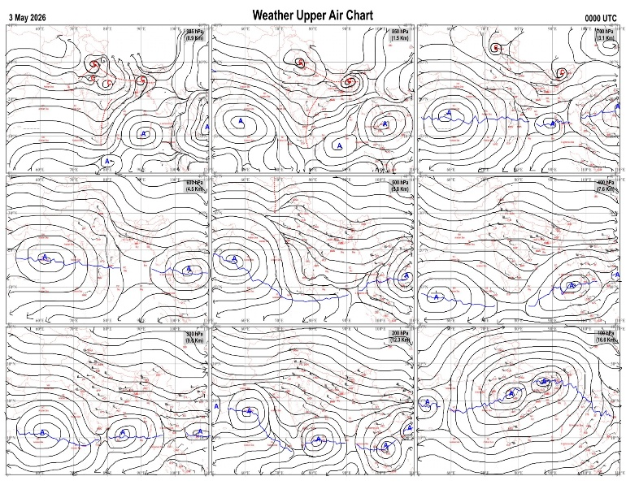
Fig.1. Analysed surface chart based on 03z observation | Fig.2. Analysed upper air chart based on 00z observation
V. K. Shripad
Scientific Officer ‘I’
CR & S Office, Pune  Issued at 1245 hrs. IST |  | Weather Forecasting Division  CR&S, Pune

Indian regions | Realised rainfall (chief amount in cm during past 24 hrs):
East | most places: Nagaland-Manipur-Mizoram-Tripura+  many places: Arunachal Pradesh, Assam & Meghalaya+, Gangetic West Bengal and Odisha  a few places: Sub-Himalayan West Bengal & Sikkim  isolated places: Jharkhand and Bihar  Kailashahar AP 6.9, Bhumuraguri 6.8, A p ghat 6.5, Sonamura & Chilika 6.3 each, Dharmanagar / panisagar 5.8, Labpur 4.4, Cherrapunji 4.2, Nuagada 3.8, Chakulia 3.4, Naharlagun AWS 2.8, Latehar balumat kvk AWS 2.5, Alipurduar PTO, Gyalsing PTO & Puri 2.4 each, Jhargram PTO & Bankura 2.3 each, Namsai 1.4, Gangtok & Jamshedpur AP 1.2 each, Ziro & Yogapatti 0.8 each, Obra & Forbesganj 0.1 each.
North | many places: Uttarakhand and Himachal Pradesh  a few places: Jammu-Kashmir and Ladakh  isolated places: Uttar Pradesh, Haryana, Punjab and Rajasthan  Fatehpur tehsil & Pithoragarh 4.8 each, Gangolihat 3.7, Sultanpur 3.5, Mankapur & Pantnagar 3.1 each, Palampur & Chothkabarwara SR 3.0 each, Rampur bushar 2.9, Deoli 2.2, Poonch 2.1, Chandigarh, Bilaspur sadar & Nowgam 2.0 each, Chandigarh AWS, Bhakra dam nangal AWS & Mohali AWS 1.9 each, Chandigarh IAF & Bikaner tehsil SR 1.8 each, Nawabganj 1.6, Raj pura ARG & Khivensar SR 1.5 each, Aliganj & Bikaner (pbo) 1.3 each, Tonk tehsil SR 1.2, Amritsar 0.6.
Central | isolated places: Madhya Pradesh, Vidarbha and Chhattisgarh  Bareli 4.5, Badi 3.1, Jagargunda 2.2, Sukma 2.1, Narmadapuram 1.6, Balaghat-aws 1.5, Jagdalpur 1.4, Tamia 1.1, Gondia AP 0.5, Jabalpur-aws 0.4.
Peninsula | a few places: Tamil Nadu+  isolated places: coastal Andhra Pradesh, Telangana, south interior Karnataka◆ and Kerala  dry weather: Gujarat State, Konkan & Goa, Madhya Maharashtra, Marathwada, Rayalaseema and coastal and north interior Karnataka  Vadipatti 9.8, Tirupuvanam 7.9, Sompeta 5.4, Airport madurai 4.7, Vattavada AWS 4.5, Peechi AWS 3.9, Tekkali 2.1, Aswapuram 1.9, Vellanikkara 1.8, Gundala 1.3, Tuni & Bhadrachalam 0.6 each, Chikkanahalli AWS 0.2, Suttur AWS 0.1.
Islands | a few places: Andaman & Nicobar  dry weather: Lakshadweep  Long island 1.2, Iaf carnicobar & Maya bandar 0.3 each.
Table-2 Forecast / warnings (distribution of rain / thundershowers) for 7 days (valid from time of origin upto 0830 hrsIST of next day)
Sr N. |  | Sub-division Name | Day 1 | Day 2 | Day 3 | Day 4 | Day 5 | Day 6 | Day 7 | Sr. No. | Sub-division Name | Day 1 | Day 2 | Day 3 | Day 4 | Day 5 | Day 6 | Day 7
 |  |  | 03 May | 04 May | 05 May | 06 May | 07 May | 08 May | 09 May |  |  | 03 May | 04 May | 05 May | 06 May | 07 May | 08 May | 09 May
 | 1 | Andaman Nicobar Islands | I | S | I | I | S | S | S | 19 | west Madhya Pradesh | I  | I  | I  | I  | I  | I | I
 | 2 | Arunachal Pradesh | W +  | W+ | F +  | F  | F  | F | S | 20 | east Madhya Pradesh | I  | I  | I  | I  | I  | I | I
 | 3 | Assam-Meghalaya | W +  | W+  | F +  | F  | F  | F | S | 21 | Gujarat region | D | D | D | D | D | D | D
 | 4 | Nagaland-Manipur-Mizoram-Tripura | W +  | W+  | F  | S  | S | I | I | 22 | Saurashtra and Kutch | D | D | D | D | D | D | D
 | 5 | Sub Him West Bengal/Sikkim | W +  | W+ | W+ | W  | F | S | S | 23 | Konkan and Goa | D | D | D | D | D + | D + | D+
 | 6 | Gangetic West Bengal | F  | W+ | W  | F  | S | S | S | 24 | Madhya Maharashtra | D | D | D | D | I | I | D
 | 7 | Odisha | I  | S  | S  | S  | I  | I  | I  | 25 | Marathwada | D | D | D | I  | I  | I | D
 | 8 | Jharkhand | I  | S | S  | S  | S | S | S | 26 | Vidarbha | I  | I  | I  | I  | I  | D | D
 | 9 | Bihar | S  | S +  | S  | I  | I  | I  | I  | 27 | Chhattisgarh | I  | I  | S  | I  | I  | I | I
 | 10 | east Uttar Pradesh | I  | S | S  | S  | S | I | I | 28 | Coastal Andhra Pradesh and Yanam | I + | S + | S+ | S + | I+ | I | I
 | 11 | west Uttar Pradesh | I  | S | S  | S  | I | I | I | 29 | Telangana | I  | I  | S  | S  | S  | S | S
 | 12 | Uttarakhand | F  | W +  | F  | S | S | S | I | 30 | Rayalaseema | I  | I  | I  | I  | I  | I | I
 | 13 | Haryana,Chandigarh and Delhi | I  | F | S | I | I | I | I | 31 | Tamil Nadu, Puducherry and Karaikal | S +  | S +  | S+  | S + | S+  | S+ | S+
 | 14 | Punjab | I  | F | S | I | I | I | I | 32 | Coastal Karnataka | I | I | I | I | I | I | I
 | 15 | Himachal Pradesh | W  | W | F | S | S | I | I | 33 | North interior Karnataka | I | I | I | I | I | I | I
 | 16 | Jammu-Kashmir and Ladakh | W  | W | S  | I | I | I | I | 34 | South interior Karnataka | I  | I  | S+ | I +  | S + | S + | S +
 | 17 | west Rajasthan | I  | I | I  | I  | I | I | I | 35 | Kerala and Mahe | S +  | S +  | F+ | F + | F+  | F+ | F+
 | 18 | east Rajasthan | I  | I | I  | I  | I | I | I | 36 | Lakshadweep | S  | S | S | S | S | F | F
Legends: D = Dry I =isolated S = Scattered F = Fairly widespread W = Widespread #= heavy to very heavy rain at a few places with extremely heavy rain at isolated places+++= heavy rain at a few places with very heavy rain at isoIated places++= heavy to very heavy rainfall @=isolated exceptionally heavy rainfall+ = heavy rain ●/*= rain or snow ♦ = very light rain ≡=fog = thunderstorm with lightning =Squall / Gusty / gale / strong wind -=cold wave/cold day + = heat wave/warm night/hot and humid weather =Duststorm =ground frost = Hail.

Fig. 4: Districtwise warnings for five days for Maharashtra State
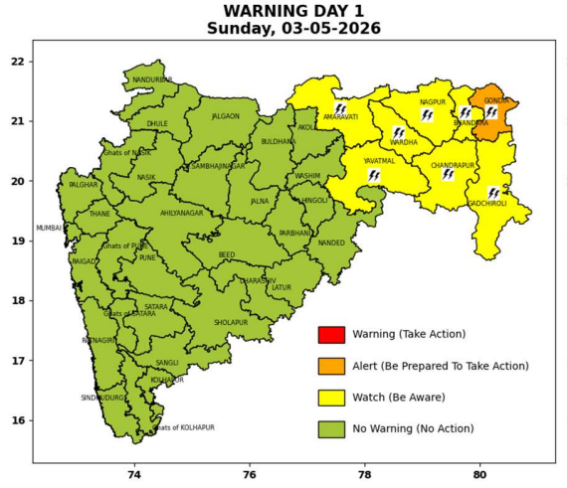 | 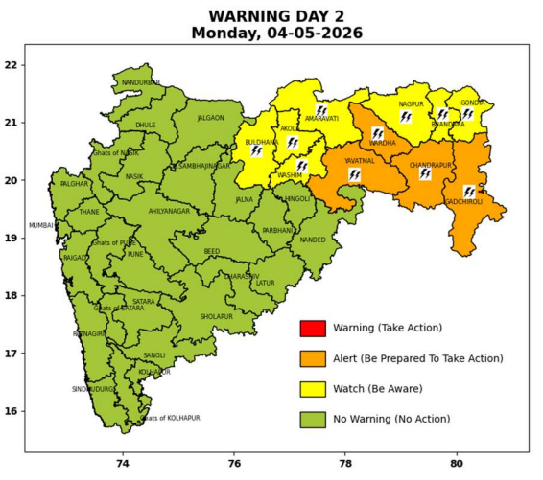 | 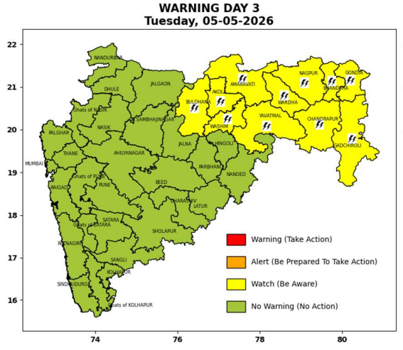 | 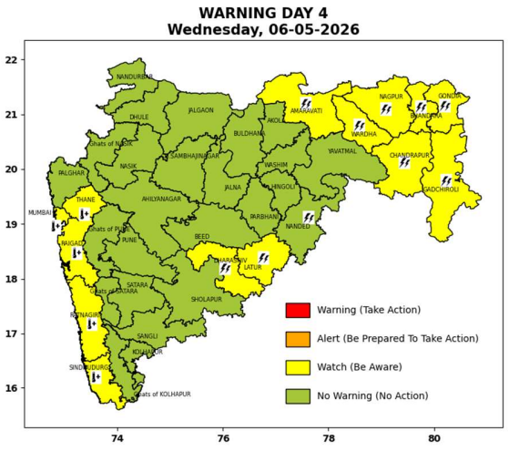 | 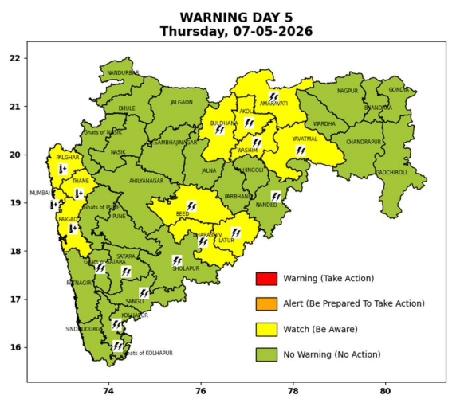

Pune, Lohegaon and Pashan observations at 0830 hrs. IST of Today
 | Temperature (°C) |  |  |  |  | Humidity (%) |  |  |  | Rainfall (mm)
 | Max.  past  24 hrs | Dep.  from  normal | Min.  past  24 hrs. | Dep.  from  normal | Dry  Bulb | At 0830 hrs. IST | Dep.  From  normal | At 1730  hrs. IST of y’day | Dep.  from  normal | Past  24 hrs. | Since  1st March | Dep.  from  normal
PNE | 37.0 | -1.5 | 22.0 | 0.4 | 27.0 | 64 | 14 | 27 | -1 | 0.0 | 92.8 | 76.5
PSN | - | - | - | - | - | - | - | - | - | - | - | -
LHG | 39.7 | 1.7 | 24.0 | 3.0 | 29.3 | 50 | -3 | 22 | -5 | 0.0 | 91.4 | 72.6

 |  |  |  |  |  |  | Local (Pune and neighbourhood) forecast
Max./Min. Temperature (°C) |  |  |  |  |  |  |  |  | Weather
Date | Pune | Pashan | Lohegaon | Chinchwad | Lavale | Magarpatta | NDA | Koregoan park
03/05/26 | 38 / 22.0* | 37 / - | 40 / 24.0* | 36 / 23.7* | 37 / 19.8* | 38 / 24.9* | 37 / 19.8* | 38 / 24.8* | Mainly clear sky.
04/05/26 | 37 / 22 | 37 / 22 | 40 / 24 | 36 / 24 | 37 / 20 | 38 / 25 | 36 / 20 | 37 / 25 | Mainly clear sky.
05/05/26 | 38 / 22 | 38 / 22 | 41 / 24 | 37 / 24 | 38 / 20 | 39 / 25 | 37 / 20 | 38 / 25 | Mainly clear sky.
06/05/26 | 38 / 23 | 38 / 23 | 41 / 25 | 37 / 25 | 38 / 21 | 39 / 26 | 37 / 21 | 38 / 25 | Mainly clear sky becoming partly cloudy sky towards afternoon / evening.
07/05/26 | 37 / 23 | 37 / 23 | 40 / 25 | 36 / 25 | 37 / 21 | 38 / 26 | 36 / 21 | 37 / 25 | Mainly clear sky becoming partly cloudy sky towards afternoon / evening.
08/05/26 | 37 / 23 | 37 / 23 | 40 / 25 | 36 / 25 | 37 / 21 | 38 / 26 | 36 / 21 | 37 / 25 | Mainly clear sky becoming partly cloudy sky towards afternoon / evening.
09/05/26 | 37 / 23 | 37 / 23 | 40 / 24 | 36 / 24 | 37 / 20 | 38 / 25 | 36 / 20 | 37 / 25 | Mainly clear sky becoming partly cloudy sky towards afternoon / evening.
* = realized temperatu
Mumbai (Colaba) |  |  |  | Nagpur (AP)
Date 2026 | T max °C | T min °C | Weather | T max °C | T min °C | Weather
03/05/26 | 35 | 28 | Partly cloudy sky. | 43 | 25 | Thunderstorm accompanied with lightning & gusty winds(30-40kmph).
04/05/26 | 35 | 27 | Partly cloudy sky. | 43 | 25 | Thunderstorm accompanied with lightning & gusty winds(30-40kmph).
05/05/26 | 35 | 26 | Mainly clear sky. | 42 | 25 | Thunderstorm accompanied with lightning & gusty winds(30-40kmph).
06/05/26 | 36 | 26 | Clear sky. Hot and Humid. | 43 | 26 | Thunderstorm accompanied with lightning & gusty winds(30-40kmph).
07/05/26 | 36 | 27 | Clear sky. Hot and Humid. | 44 | 28 | Mainly clear sky.
08/05/26 | 36 | 27 | Clear sky. Hot and Humid. | 43 | 26 | Mainly clear sky.
09/05/26 | 35 | 26 | Mainly clear sky. | 44 | 26 | Partly cloudy sky.
Rainfall Distribution |  |  |  |  | Rainfall Categories | Rainfall (mm) | Cloud condition |  | Rainfall Intensity | Range
Widespread (W) | 76-100% |  |  |  | Very Light rain | Trace to 2.4 mm | Mainly clear sky | 1-2 oktas | Light Spell | 1 cm/hr
 |  |  |  |  | Light rain | 2.5 to 15.5 mm | Partly cloudy sky | 3-4 oktas | Moderate Spell | 1-2 cm/hr
Fairly Widespread (FW) | 51 – 75% |  |  |  | Moderate rain | 15.6 to 64.4 mm | Generally cloudy sky | 5-7 oktas | Intense Spell | 2-3 cm/hr
Scattered (S) | 26 – 50% |  |  |  | Heavy rain | 64.5 to 115.5 mm | Overcast | 8 oktas | Very Intense Spell | 3-5 cm/hr
Isolated (I) | 1 – 25% |  |  |  | Very heavy rain | 115.6 to 204.4 mm |  |  | Extremely Intense Spell | 5-10 cm/hr
Dry (D) | No Rain |  |  |  | Extremely heavy rain | ≥ 204.5 mm |  |  | Cloudburst | > 10 cm/hr
Probability Terms in %: |  |  |  |  | Heavy snow | 6.5 to 11.5 cms water equivalent of rain
unlikely | < 25 |  |  |  | Very heavy snow | 11.6 to 20.4 cms water equivalent of rain
likely | between 25 50
very likely | between 51 75
most likely | >75

